
Alzheimer’s disease is one of this country’s most pervasive afflictions and will touch almost everyone in their lifetime, even if not directly; by affecting someone that is a friend or family member.



Many people will complain about lacking funds for research and care for those that have such a common ailment and so much is needed to assist, and this is definitely true, but they won’t really do anything about it.

Now there is an opportunity for
YOU
to do something that can help!

You don’t have to be a marathon level athlete, or the most liberal giving person in the world to come out and donate some of your time to take a walk for awareness. Help raise money to for these people that have this affliction, and those that are trying to make their lives better every day.


Utah is a beautiful place and we have some of the most varied landscape in the nation, let’s bring our fantastic people to these fabulous places for a cause.



JOIN US
2012 Walk to End Alzheimer's Salt Lake County - Salt Lake City, UT

Location:
Murray Park

Date and time:
9/8/2012

For more information please go to http://www.alz.org


The state chapter of your local Alzheimer’s association has walks in the works and all that you need to do is help in any way you can.

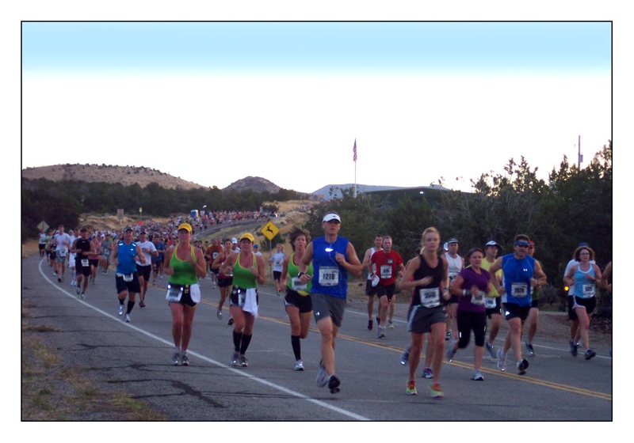
Here are some ideas to get you started!
Register. It takes just a few minutes online.
Start a team. Participating in Walk to End Alzheimer's is even more fun with a group. Ask your co-workers, family and friends to walk as a team. You'll be amazed at how many people want to help.

Fundraise. Every Walk to End Alzheimer's participant is asked to raise money for the fight against Alzheimer's. The Alzheimer's Association staff are ready to support you every step of the way with tips, tools and advice.

Get Creative. Raise money with our online tools, hold a fundraising event or ask for a donation when you're face-to-face.

Walk! Walk to End Alzheimer's is a unique experience. See the difference you can make as we walk to change the course of Alzheimer's together.

Works Sited
- www.examiner.com - Image – slc.jpg
- www.actierain.com - runners.jpg
- www.alz.org - blue_brain.jpg
- www.alz.org - Date and time information for event.
- www.alz.org - Walk to End Alzheimer’s image and trademark.

