Chad Stonehocker
Dennis Wilson
Economics 2020
28 July 2012
Term Paper

U.S. Financial System Bail-Out
It has been said that the Bail-Out was a good thing and that without it we would still be struggling mightily and the great Recession would have possibly become another great depression as we experienced in years past. Others have stated the exact opposite that if the government had not stepped in and thrown money as a lifeline to failing businesses and banks that the U.S. Economy would survive with minimal impact after new business had stepped in where there would be an opening to run things better. The U.S. market system has securities and procedures which have been put in place since the great depression that are intended to protect the economy from falling from a recession cycle to a depression. It would be logical to assume that the U.S. would have recovered in the same rate if not even better with or without the bail-out and the businesses that failed should fail since obviously their business models were so poor as to allow the failure, and isn’t that why we have the market system that we do?
On the surface of things we might be upset since it seems that anyone can tie their business into so many other businesses that if your new model is to set everyone else up for failure. If you fail this could be a winning strategy since we can get Uncle Sam to come to your rescue with American tax dollars and you may or may not have to pay them back after everything sorts itself out! As with everything in the modern financial climate it is never as simple as we would assume, especially if we only look at the surface of the issue as most news broadcasts do since they are looking for sensational and news worthy material to entertain more than educate the public in general. I believe that the Bail-Out was a good and necessary thing, but I believe that as a result of this situation we as a nation need to look much more closely at how the nation and world have become a quagmire of interconnectivity that has no way to halt the Domino effect of collapsing economies when things go wrong. This can be caused by companies and even nations with poor fiscal policy and financial accountability.
We are all aware that the economy runs in cycles and that ups and downs are to be expected and can even be anticipated to a certain degree. It is when the unexpected happens and the market reacts in a scared or uncertain way that usually leads to a collapse. Our economy only works if everyone continues to participate, in the event that there is a massive failure. Our great recession really began in 2007 when two Bear Stearns hedge funds speculating in mortgage securities collapsed and the panic reached a peak in September of 2008 when Lehman Brothers went bankrupt¹. Stating that the market can react in an emotional way is of course a simplification of the way that individuals and business that must participate in the economical environment behave. Everyone that is lending or borrowing money, has a wage or earnings, or buys or sells an item has to participate in the global monetary system. Now that we have established that we all must participate we are justifiably concerned when our elected officials choose to give away what we perceive is ours, due to the fact that it is from the population that tax dollars are earned. When we borrow money from ourselves and inflate the national debt, reduce the value of the dollar compared to other nations currency and increase the time it takes to strengthen our dollar by diluting it’s buying power and raising inflation there should be some tangible benefits down the road.
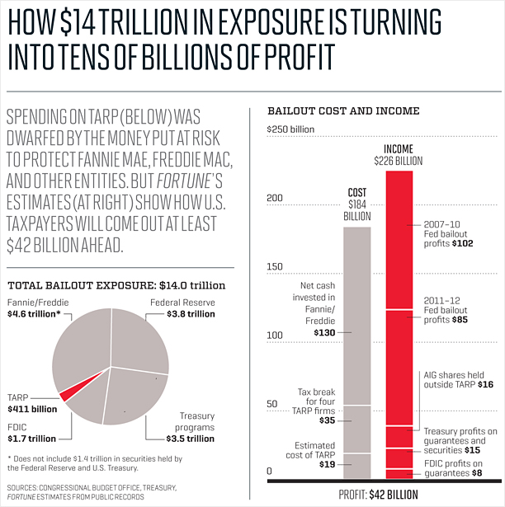
When the bail-out first occurred it was looked upon by skepticism by the global community, but I wonder if they saw the global impact of what was coming and how it was not just the United States that was going to have to come up with some radical solutions to some serious problems. We as a world are working with what appears to be some horrific business and banking policy globally practiced. As stated by Tim Shipman of the Telegraph, our financial system was poised to face a meltdown of the 1929 proportions unless U.S. politicians succeeded in their efforts to rescue the collapsing system by infusing seven hundred billion dollars into TARP².
It is no wonder that nobody knows how well or poorly the bail-out helped or hurt the U.S. and Global economy, everybody uses different numbers and includes or excludes assets or expenses to fit their concept of where we are. Overall I believe that after we consider where the government put money and where it is today, it was a good decision and helped the country from going further into debt.
I think now that we have had the experience of avoiding another depression we need to evaluate our exposure to the global market and work as diligently today as we did after the great depression to shore up our policies and put in place safe guards to make it so that we can not impact or collapse foreign markets, and that they can not cause ours to collapse either. As Andrew Lo, professor of finance at the MIT Sloan School of Management stated “The impact of the next crisis will be greater because the economy is in a much more fragile state.“ ³ It’s a wonderful thing to see our economy recovering, but all it takes is another scare to go right back to where we were, but now we’re in a situation where the homes have already been repossessed, the bubble has burst, and the coffers are dry; we can’t sustain another financial crash at home so we need to insulate ourselves from foreign shock waves as quickly as possible since many of their markets have bubbles, but they haven’t burst yet and when they do we don’t want to explode right along side them.
In conclusion we have a cycle of economic gains and losses, they represent a normal and healthy market economy. Now that we have seen that we have a cycle within a cycle that leads to depression level economics it is time to take the steps needed to strengthen our fiscal policy. We as a nation need to encourage businesses take fewer risks, and make sure that no company ever feels that they are too big to fail and stops managing their affairs in a way that will ensure their growth, stability, and ongoing efficiency.

Works Cited
- finance.fortune.cnn.com – Surprise! The big bad bailout is paying off – Allan Sloan– July 8, 2011.
- www.telegraph.co.uk - Bailout failure ‘will cuse US crash’ – Tim Shipman and Edmund Conway – September 27, 2008
- www.huffingtonpost.com - Financial System Riskier, Next Bailout Will Be Costlier, S&P Says – Accessed July 21, 2012

