Chad A. Stonehocker
English 2010
Dina Wecker
Feb 15 2012

Medical costs for those suffering from Alzheimer’s disease.

Taking care of anyone that has a medical condition obviously has a cost involved, but we usually believe that by treating an illness the ultimate goal is to make that person feel better and become healthy again. Unfortunately in the case of the Alzheimer’s disease the medical community can treat symptoms, but there is currently no cure. ²

Due to advances in medical care, those with disease and, or dementia live longer and healthier lives. New advances in pharmacology and investigations into the human condition allow the medical and care giving industries to extend better care to those whom need it.

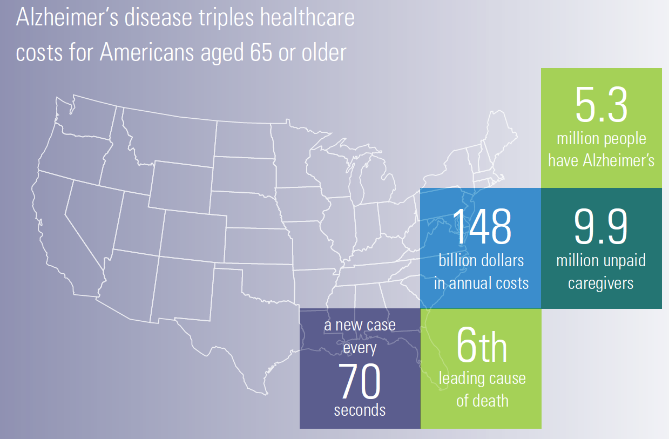
Alzheimer Facts and Figures 2009 ¹
According to a 2009 report published by the Alzheimer’s association¹ it is stated that Alzheimer’s disease and dementia triple healthcare cost for Americans age 65 and older.
There has been a great deal of investigation into the costs of treating those with Alzheimer’s disease; by evaluating the cost of treatment as well as the costs of treating other medical conditions that those afflicted with the Alzheimer’s disease also suffer from. Those with Alzheimer’s disease are perhaps more prone to suffering the same afflictions which affect most other elderly citizens.

Average Per Person Payments by Source for Health and Long-term Care Services. For Persons, Aged 65 Years and Older, With and Without Alzheimer’s Disease and Other Dementias, 2004²
Average Per Person Payments | Beneficiaries with no Alzheimer's or Other Dementias | Beneficiaries with Alzheimer's or Other Dementias
Total payments* | $10,603 | $33,007
Medicare payments | 5,272 | 15,145
Medicaid payments | 718 | 6,605
Private insurance  payments | 1,466 | 1,847
Other sources  payments | 211 | 519
HMO payments | 704 | 410
Out-of-pocket  payments | 1,916 | 2,464
Uncompensated care | 201 | 261

* Payments by source do not exactly equal total payments due to the effect of population weighting. Source: Alzheimer’s Association 2009 Alzheimer’s disease Facts and Figures

People with Alzheimer’s are high consumers of hospital, nursing home and other health and long-term care services, which will translate into high costs for Medicare, Medicaid and millions of families. As families struggle to survive in a deepening recession and as states grapple with budget shortfalls, Alzheimer’s disease threatens to overwhelm them both. Most people with Alzheimer’s also have one or more additional serious medical conditions, such as diabetes or coronary heart disease. Their Alzheimer’s greatly complicates the medical management for these other conditions and drives up costs significantly.

Studies into the duration of illness from the time of diagnosis to death in those people that are sixty-five and older is a survival rate of four to eight years. Some people are affected more severely by the disease and rapidly decline, and others may live up to twenty more years with the affliction ¹. Due to the nature of Alzheimer’s fourty percent of the total number of years that a person has the disease will be when it is in the most severe stage where the person will rely heavily on care services that are very expensive.

Those with Alzheimer’s in the most severe stage cannot care for themselves for many very specific reasons; if medication is needed they cannot recall if they took it in a timely manner, nor that they need medicine at all. Since the disease affects memory so severely people cannot recall where they live, whom they know, those that are family and friends, or those that are caregivers in many instances; thus it is not practical to think that those afflicted can take care of themselves on a daily basis without supervision.

When calculating actual costs to care giving, many hours are considered unpaid care, these are primarily family members, but also include other relatives and friends¹. Taking care of someone with Alzheimer’s is like taking care of an infant that has financial responsibilities ³ ⁴.

Reasons for Hospitalization by People with Alzheimer’s Disease:
Percentage of Hospitalized People by Admitting Diagnosis ²
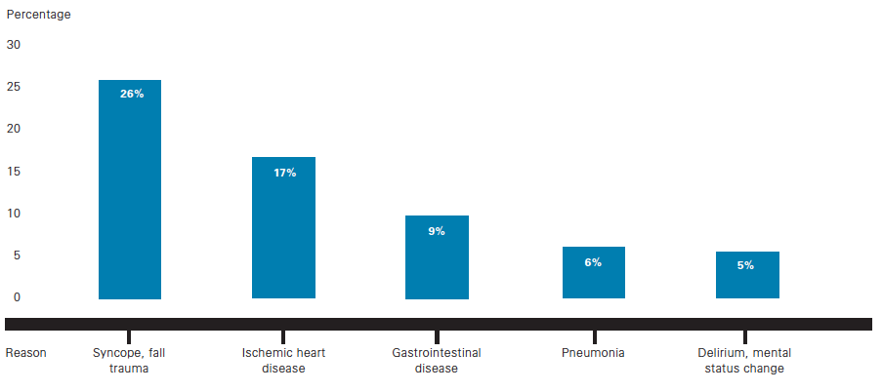

Costs for care of those with Alzheimer’s disease become excessive when those afflicted become completely dependant on hospitalization and long term care facilities are required to continue to live due to the inability of family and friends to bear the burden of care due to the deterioration of their physical and mental health to such an excessive degree.
Reduce extraordinary care for those with Alzheimer’s disease.

Extraordinary measures for healthcare are excessively expensive finding the balancing point of financial responsibility and the emotional trauma of withholding care from someone that is in medical is one of the most wrenching and contentious issues in medicine. For every patient who reaches the final stage of the disease, there typically are about five or six family members faced with decisions about whether to authorize medical treatments for patients whose bodies live on though their minds are gone ⁵.

New research has found that Alzheimer's patients at the end of their lives often receive everything that medicine has to offer. ⁵ As quoted from this New York Times article:
As an example, a recent study of nursing home patients, by Dr. Susan Mitchell of Harvard and the Hebrew Rehabilitation Home for the Aged, found that those with end-stage Alzheimer's received more aggressive medical treatment -- including feeding tubes, intravenous fluids and antibiotics and hospitalizations -- than cancer patients at the end of their lives.

But Alzheimer's patients rarely receive the palliative care intended to relieve suffering but not to prolong life that is normal in cancer cases; they make up only 7 percent of people who receive hospice care.

The comparison with cancer patients is imperfect because cancer patients often die more quickly, and, unlike Alzheimer's patients, they can speak for themselves about their care. But some experts and family members argue that intensive treatment in cases of late-stage Alzheimer's patients is inappropriate, even cruel, and that its costs are excessively high.

For family members, costs of treatment are rarely an issue, because they are mostly borne by taxpayers; Medicare and Medicaid pay for most medical and nursing home care. So some end-stage Alzheimer's patients get dialysis when their kidneys fail. Infections are treated with intravenous antibiotics. Patients are rushed to hospitals and intensive care units when they fall ill.

Putting in a feeding tube can cost about $2,000, said Dr. Douglas Nelson, a geriatrician in Hickory, whose practice mostly consists of nursing home patients. Inserting a tube requires a consultation with a speech therapist to verify that food is entering the lungs and an X-ray by a radiologist that requires swallowing barium. The procedure itself is done in a hospital, with an anesthesiologist, and a gastroenterologist or a general surgeon.

A feeding tube can prolong life in a nursing home, which quickly dwarfs the cost of inserting a tube. In North Carolina, Dr. Nelson said, it costs $150 a day on average, not counting medication, to care for a patient in a nursing home.

''The economics are horrific,'' said Dr. Steven DeKosky, director of the Alzheimer's Disease Research Center at the University of Pittsburgh.

Dr. Diane E. Meier, a professor of geriatrics and ethics at Mount Sinai School of Medicine in Manhattan, agreed. ''We are spending a huge amount of money keeping people with irreversible brain failure alive,'' she said. ''If the technology exists, we feel we must use it. Our colleagues in Europe consider what we do bizarre to the point of disbelief.''

But others contend that to withhold treatment is to hasten death, in effect, playing God.

''There are people in my field who have legitimate concerns that we might be too eager to pull the plug,'' said Dr. Christine Cassel, an expert in geriatrics, ethics and end-of-life care, and president and chief executive of the American Board of Internal Medicine. ''Just because someone has Alzheimer's disease doesn't mean their life has no value.''

With tube feeding and medical treatment for each crisis, end-stage Alzheimer's patients can live on, sometimes for years. Many no longer recognize family members, speak only a word or two, cannot walk or eat, and are prone to pneumonia and repeated urinary tract infections.

Looking at the big picture with statistics and rational evaluations of dollars and cents makes a great deal of sense when we can be analytical and remove ourselves from the emotional aspect of health care, but when it is the family and friends of a stricken individual that must make the hard decisions of withholding medical services it is no longer analytical; it becomes personal and profound.

The American health care system is based on the premise that medical providers are doing no harm. Unfortunately like the Constitution of the United States, the reason that the statement is so successful is that it is general and open to interpretation of the one that is evaluating what harm is.

The medical community categorizes Alzheimer’s disease by the ability to treat; it is currently the convention to state that there is no cure, but treatment is available. The Treatment is categorized by considering the disease Mild to Moderate, or Moderate to Severe. When the disease goes beyond a moderate case to severe it may be time to withhold care that would be considered life extending, such as feeding tubes and respirators. The drugs that are currently used to treat moderate to severe Alzheimer’s may help a patient in the later stages of the disease to maintain his or her ability to use the bathroom independently for sever more months. ⁶ Consumer Reports has evaluated a variety of drugs that are currently utilized for treatment and concludes: ⁷
Cost. Averaging $148 to $195 a month, the Alzheimer's drugs are costly and may not be worth the added cost if the patient must take many other medicines. This is true even if insurance or Medicare coverage helps pay since out-of-pocket payments can still be quite steep.

Currently the fastest growing population in America is people over the age of 65, which are also the population at greatest risk of developing Alzheimer’s disease.¹ While progress has been made, available treatments are still limited and no means of prevention is available today. So Alzheimer’s disease poses a growing challenge to quality of life and the healthcare system:

- Costs of Alzheimer’s disease exceed $148 billion a year.¹ ⁸
- State and federal Medicare spending for nursing home care is expected to reach $32 billion by 2025.⁸
- New cases of Alzheimer’s disease are expected to triple or quadruple over the next 30 to 40 years.¹

As America ages and there are ever new advances in medicine that may be used to extend life beyond its current limits, do we want to put monies toward research and development or to prolong life that may not be worth living any longer. If given the choice it would be believed that a rational person would choose to pursue quality of life over quantity of life if that life was not worth the effort of extension.


Image: © IMAGES.COM/CORBIS
Works Cited

- 2009 Alzheimer’s disease Facts and Figures; www.alz.org
- 2011 Alzheimer’s disease Facts and Figures; www.alz.org
- Unpublished data from a 2009 National Alliance for Caregiving/AARP survey; data were prepared for the Alzheimer’s Association under contract with Matthew Greenwald and Associates, Nov. 11, 2009.
- MetLife Mature Market Institute, The MetLife Study of Alzheimer’s Disease: The Caregiving Experience, August 2006.
- When Alzheimer's Steals the Mind, How Aggressively to Treat the Body?, The New York Times, GINA KOLATA, May 18, 2004
- Alzheimer's Disease Medications Fact Sheet, National Institute on Aging (NIH.gov), July 2010
- Alzheimer’s Drugs: Summary of Recommendations, ConsumerReports.org
- Hobbs FB. The Elderly Population. US Census Bureau Decennial Census, Population Estimates and Projections.

