Chad Stonehocker
Dina Wecker
English 2010
16 April 2012

Alzheimer’s discovered and defined
Alzheimer’s is a type of dementia that causes problems with memory, thinking and behavior, it is the advent of modern medicine that allows us to see that there is a medical diagnosis, and society shows us the economical and personal costs to this disease.
Alzheimer’s disease as defined by the Mayo Clinic is a disease that gradually gets worse, it’s the most common cause of dementia that cause progressive loss of intellectual and social skills, severe enough to interfere with day-to-day life¹. Bain cells degenerate and die which causes a steady decline in mental function.
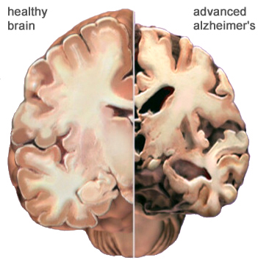
AD was discovered in 1907 by Alois Alzheimer, but was not considered a major disease or disorder until the 1970s. Alzheimer performed an autopsy on a patients brain using a silver staining technique that allowed him to visualize the presence of neurons. In the process he found unusual formations, now known as senile plaques and neurofibrillary tangles¹.

In the very early 1900’s when Dr. Alois Alzheimer identified a collection of brain cell abnormalities as a disease there have been many scientific breakthroughs in AD research. The plaques and tangles in the brain have been linked to cognitive decline since the 1960s and this was when it was generally recognized that senility was not a natural part of aging³. The following decade of the 70s saw great strides in understanding of the human body in general of which AD was an are of great research interest. In the 1990s gene research was performed to determine AD susceptibility and drugs were approved to treat the symptoms that affected cognitive function as a result of the disease. At this time AD is still incurable, although over the last decade there have been great advances in determining risk factors, isolating genes related to the onset of the disease, both early and late; genetic factors have to be weighed against environment and lifestyle of those afflicted to determine more accurately the cause of the affliction.
Alzheimer’s disease exhibits physical conditions prior to symptoms being evident; these symptoms are described in three general stages of progression.

Mild (stage 1) | In addition to minor memory loss and difficulty learning, first-stage Alzheimer’s disease may cause a loss of energy and spontaneity, as well as mood swings, confusion, trouble communicating, and difficulty organizing³.
Moderate (stage 2) | During the second stage of Alzheimer’s disease, the afflicted individual begins to need help carrying out anything but simple tasks. Recent events and personal histories may be lost and the present confused with the past. Familiar people may not be recognized, as well as in speaking, reading, writing, and dressing. At this stage the disease is showing that the afflicted person is becoming disabled³.
Severe (stage 3) | Third-stage Alzheimer’s disease brings full-blown disability, with possible loss of the ability to feed oneself, to speak, to recognize people and to control bodily functions. At this final stage of the disease the memory is further weakened to the point where it is almost completely gone and their physical state will weaken and cause vulnerability to other diseases³.
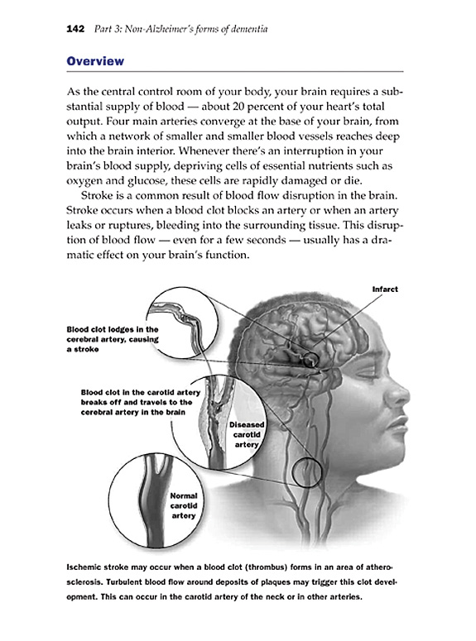
⁴
Alzheimer’s costs are not all fiscal
The function of the brain and the needs of the circulatory system are delicately balanced; and when any process of blood flow to the brain occurs, damage is inevitable².
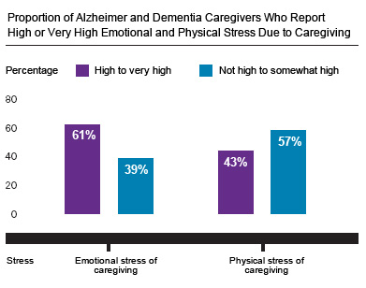
There are many costs related to this disease, of which purely financial may be the easier burden to bear, there are currently nearly fifteen million Alzheimer’s and dementia caregivers providing seventeen billion hours of unpaid care. Caregivers not only suffer emotionally, but also physically because of the toll on their own health².
In isolating the affect on individuals, and communities in terms of cost, it is important to understand that Alzheimer’s disease is one form of dementia, but not the only one. The decline in thinking, reasoning, and / or remembering is Dementia. People with difficulty carrying out daily tasks they have performed routinely and independently throughout their lives due to a loss in mental faculty is identified as a form of dementia¹. Vascular dementia is a hardening of the arteries in the brain that cause blockage in blood flow, it is one of the two most common forms of dementia; the other is Alzheimer’s disease³. Due to the fact that both of these most common forms of dementia do harm to the brain it is irreversible, there are ways to treat symptoms; however it is necessary to stipulate that actual harm is being done to the brain and this damage is the cause of the symptoms exhibited by the afflicted individual.
Knowing that there is a disease that progressively is counted more toward the causes of death every year as the American society ages, but is being investigated and analyzed extensively shows us that there is hope for a better future for those afflicted and those that treat them.
Works Cited
- Petersen, M.D., Ph.D. “Mayo Clinic Guide to Alzheimer’s Disease” 2008 http://www.mayoclinic.com/health/alzheimers-disease/DS00161/DSECTION=causes
- Alzheimer’s Association – “Alzheimer’s Statistics” – 2008, 1/30/2012 http://www.alz.org/alzheimers_statistics_2008.asp
- Alzheimer’s Association, “Alzheimer’s Facts and Figures” 2011, 1/30/2012 http://www.alz.org/alzheimers_disease_facts_and_figures.asp
- Alzheimer’s Disease Research, “A History of Alzheimer’s Disease” 2012, 1/30/2012 http://www.ahaf.org/alzheimers/about/understanding/history.html

