Group Proposal
James Ford & Chad Stonehocker
Alzheimer’s Association
The Alzheimer’s disease has 224 nonprofit organizations listed on greatnonprofits.org. The disease killed 5.4 million people last year and that number is increasing on an annual basis. The ultimate goal for these nonprofit organizations should be structured around finding a cure for this disease and riding the world of it altogether. The nonprofit that leads the way in finding a cure for the Alzheimer’s disease is the Alzheimer’s Association located on the website www.alz.org. The best way to accomplish the goal of a cure is to have all the nonprofit organizations merge together with the Alzheimer’s Association to form a monopoly to fight the disease. The resources from all the nonprofits could be pooled together and used to find the means for a cure.
Alzheimer’s disease is one of the least funded diseases when it comes to research and finding a cure for the disease. Many nonprofits have donated millions of dollars to researchers to help them find a cure for the disease. The Cure for Alzheimer’s Fund has donated $15,846,141 to the research of finding a cure for Alzheimer’s disease. The total has taken place over an eight year span, which means around two million dollars is raised by them every year. The Alzheimer’s Community Care has raised three million dollars this year. The two companies combined don’t come close to the Alzheimer’s Association, which raised $24,950,000 towards the research of the disease. The number is four times greater than both of those companies combined.
The Alzheimer’s Association has been around for 33 years of experience dealing with the disease and they have established 75 chapters of their organizations all over the United States. The Cure for Alzheimer’s Fund has only been around for an eight year span and established two organizations through the United States. The Alzheimer’s Community Care has only one established organization in their 15 year existence as a nonprofit organization. The Alzheimer’s Association has a reach that spans over the entire United States, while other organizations only reach a tiny portion of the continent. The Alzheimer’s Association has the experience and expertise to help achieve the ultimate goal of curing Alzheimer’s disease.
The best means to conquer the Alzheimer’s disease and find a cure for this disease is to create a monopoly nonprofit dedicated to Alzheimer’s disease. The organizations with the best means to create the monopoly are the Alzheimer’s Association due to the vast resources they have set up in their years as a nonprofit organization. The other nonprofits dedicated to Alzheimer’s disease should put all their assets into combining forces with the Alzheimer’s Association. The combination of nonprofit organizations has good qualities along with bad qualities. The bad things that could come up in the monopoly of Alzheimer’s disease are lack of quality patient care on an individual level due to the massiveness of the company. The individual regions could have their needs passed over for the massive needs of the company as a whole. The massive company would be susceptible to corruption by the people at the top of the nonprofit organization. The good things that would come out of the monopolizing Alzheimer’s nonprofits are the existing chapters located throughout the United States. The Association has developed the processes necessary to gain a cure for the disease. The Association already has established the knowledge necessary to head towards the goal of a cure for Alzheimer’s.
The Alzheimer’s Association has the best means to create the monopoly necessary to find a cure for Alzheimer’s. The Association has the most funds established to create research to find a cure. The local chapters are established throughout the United States to spread the news and find a cure quicker. The overall best strategy to find a cure for Alzheimer’s has been set up by the Alzheimer’s Association and the other nonprofits should supply their resources to help them with their cause.
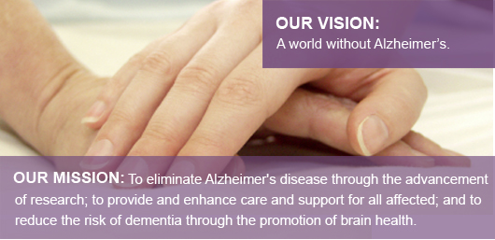
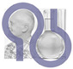
The brand of the Alzheimer's Association represents who they are and what they do. It is both a visual symbol of their dual mission of people and science and a commitment that guides them in their daily work in research, advocacy, education and support.

