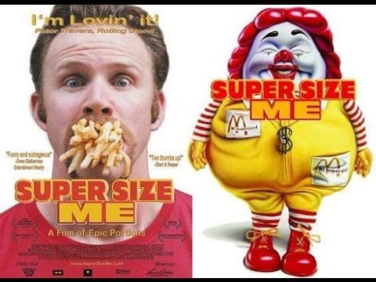

Super Size ME
  - Our Daily lives?
Chad Stonehocker | HLTH-1020 | 4/21/2017

The documentary may have been called Super-Surprise Me!
What an amazing thing, to look at something so simple as where we are going for a quick meal as a society in 2004 and how trends if they continue are taking a known issue, and making it a global catastrophe as the world adopts a fast food mentality. The film maker inserts himself into a lifestyle of eating three meals a day from one targeted fast food restaurant and interspersing the whole documentary with food facts of other impacts of the American diet and how from a very early age the industries that market to the American public specifically use well known, and proven techniques to associate their products to positive emotions and comfort more importantly than the quality of the products themselves. The goal is to secure their customer base for the present day, and well into the future.
I selected Super Size Me by writer and director Morgan Spurlock where the author of the story puts his personal health on the line by changing his normal diet to eat exclusively at the fast food restaurant McDonalds where he sets himself some basic rules to follow the “normal American diet, and exercise lifestyle” for one month. (IMDB.com)
Morgan Spurlock doesn’t profess to have any special education, training, or involvement in the nutrition world, other than his own personal experiences and feedback from health professionals that he consulted with during the course of creating his documentary. Admittedly with any documentary or piece of work, there is always a story angle and perceptions based upon the facts presented and intuited by the subjects. Spurlock is a film maker whom has focused on reality television and documentary where he inserts himself into the lifestyle of his subject matter for a short time to better project information on how that real situation impacts him on a personal level. (tribute.ca)

is it applicable today?
How could this view not be applicable today? The food industry that was in place in corporate and commercial America is the heart of how we do business. As long as there is free enterprise and lack of concern on the consumers’ part to do a deep dive into the health choices of where we spend our dollars, the fast food industry can’t help but survive and thrive.
There is a great deal of commentary on this documentary that continues open dialogue and discussion even to the date that I create this report. From the comparisons of daily allowance of vitamins, and minerals as we have thoroughly covered in our class material to the conversation with the nutritionist in the film, McDonald’s doesn’t sell a multi-vitamin, nor do they have products that meet all of the daily recommended allowances of many of our daily dietary needs. We can find some vegetables, and some fruit, but even their purported healthy options have in many cases more calories, saturated fat, and sugar than their dessert items such as a Milk Shake. Do we see antioxidants and other beneficial or necessary components of our diet from McDonalds, the author indicates that some are there, we have yogurt, and chocolate milk which are high in sugar and calories due to the way there are almost always sugar additives to any items available. Most importantly of the items we need in our daily diets for overall health as we have learned are less processed foods as the more we process our food products, the less we have in the way of nutrition.

What can we learn from this examination
Learning and discussion is always a personal journey, as with any examination I found that my take away was how the industries of our nation, whether it be “big tobacco”, the food industry where it pertains to a conglomeration of like-minded companies to come together for common cause to protect their interest for a consolidated cost and analysis derived incentive that profit, shareholders, growth and stability are one of the most important aspects of a capitalistic society such as ours. However, Americans have two excellent voting methods. First, we get to vote as a citizen right and duty, to help enable for stringent regulations for these companies, if we put forth effort to learn about the topics and drive change through our governmental leadership, such as where in the film local governments allowed school boards to ban soda and sugary snacks from vending machines to their students to provide more healthy options. Secondly we have to corporate America maybe a more powerful vote, the ability to vote with our dollars. This is possibly the more difficult aspect for Americans to use wisely. We find ourselves by the very nature of our lives where most families live in broken homes, we don’t value the home cooked meal and time to gather as a family as we once did to teach our children how to prepare their own meals, evaluate good and nutritious choices, and in some instance, have access to grocery stores to allow for the purchase of fresh food that is healthier than the fast food equivalents which are more prevalent due to the higher profit margins of those sales. dietary needs.
I find that in my own life I have gone back and forth just as many of us have in regards to fast food. I get a new job, my schedule changes and I find that I haven’t made time to prepare a healthy meal to take with me to work, so I just tell myself on my drive; “oh I’ll just pick something up today, it’s not that bad”. Then when I head out to get something to eat I have to consider how much time I have from the moment I punch out, until I punch back in. Where can I go to get a meal, I don’t have a lot of time to wait so I best head to McDonalds, Crown Burger, KFC, or some other place that has my food almost ready before I ask for it so that I can get back to work and clock in. I need to take my own ideas and make them a firmer part of my life of realizing that I need to make the extra effort to prepare more nutritious meals and take them with me so that I am not pressed for time and make bad decisions as many of us do. I mean, it’s not like we can’t figure out how bad it is for us. Many nonprofit companies go out of their way to do the research for us broken down by specific Restaurants. (nutrition)

Works Cited
IMDB.com. Super Size Me. 11 June 2004. Web Page - http://www.imdb.com/title/tt0390521/. 21 April 2017.
nutrition, fast food. fast food nutrition. n.d. web page - http://fastfoodnutrition.org/. 21 april 2017.
tribute.ca. Morgan Spurlock biography. n.d. Web Page - http://www.tribute.ca/people/morgan-spurlock/12577/. 21 April 2017.

