Chad A. Stonehocker
Political Science 1100
Bill Greer
Feb 15 2012

Electoral College method of Presidential and Vice President position

I believe that the method of election for our President and Vice president by using the Electoral College method is antiquated and unnecessary at this point in our new democracy. Due to advances in technology and communication capabilities I can not fathom why the American infrastructure follows a process of picking someone through our common vote to then hope that they in turn vote in a way that we would like, but can’t guarantee is the way we would have voted. The elected voter can choose any way that they personally feel is appropriate even though it could be contrary to the popular vote that was used to give them the opportunity to choose.

The Electoral College, administered by the National Archives and Records Administration (NARA), is not a place. It is a process that began as part of the original design of the U.S. Constitution. The Electoral College was established by the founding fathers as a compromise between election of the president by Congress and election by popular vote. The people of the United States vote for the electors who then vote for the President.¹

At the time where the compromise was needed was at a time where each person that was able to vote could not readily be tallied, and verified as accurate. Perhaps at this time we could have the direct popular vote that would have been so terribly difficult at that time. This is not a new idea, but one of the possible downfalls of this type of change is built directly into the system that perpetuates its use. As sited in the frequently asked questions from the government site of archives frequently asked questions for NARA.

Why do we still have the Electoral College?

The Electoral College process is part of the original design of the U.S. Constitution. It would be necessary to pass a Constitutional amendment to change this system.

Note that the 12th Amendment, the expansion of voting rights, and the use of the popular vote in the States as the vehicle for selecting electors has substantially changed the process.

Many different proposals to alter the Presidential election process have been offered over the years, such as direct nation-wide election by the People, but none have been passed by Congress and sent to the States for ratification. Under the most common method for amending the Constitution, an amendment must be proposed by a two-thirds majority in both houses of Congress and ratified by three-fourths of the States.²

I am definitely not alone in my opinion as also seen in the frequently asked questions for the NARA list that reference sources indicate that over the past 200 years, over 700 proposals have been introduced in Congress to reform or eliminate the Electoral College. There have been more proposals for Constitutional amendments on changing the Electoral College than on any other subject. The American Bar Association has criticized the Electoral College as "archaic" and "ambiguous" and its polling showed 69 percent of lawyers favored abolishing it in 1987. But surveys of political scientists have supported continuation of the Electoral College. Public opinion polls have shown Americans favored abolishing it by majorities of 58 percent in 1967; 81 percent in 1968; and 75 percent in 1981.³

We as Americans are given the most opportunity to voice our opinion and position on any aspect of our governance by being free to get involved and our vote is our powerful tool, as the President has a Veto; we have our vote. Considering how important each power is, it is understandable that many detractors of the “Popular Vote” methodology that I am proposing may be against it as voter turnout remains low as compared to those that are eligible to vote.
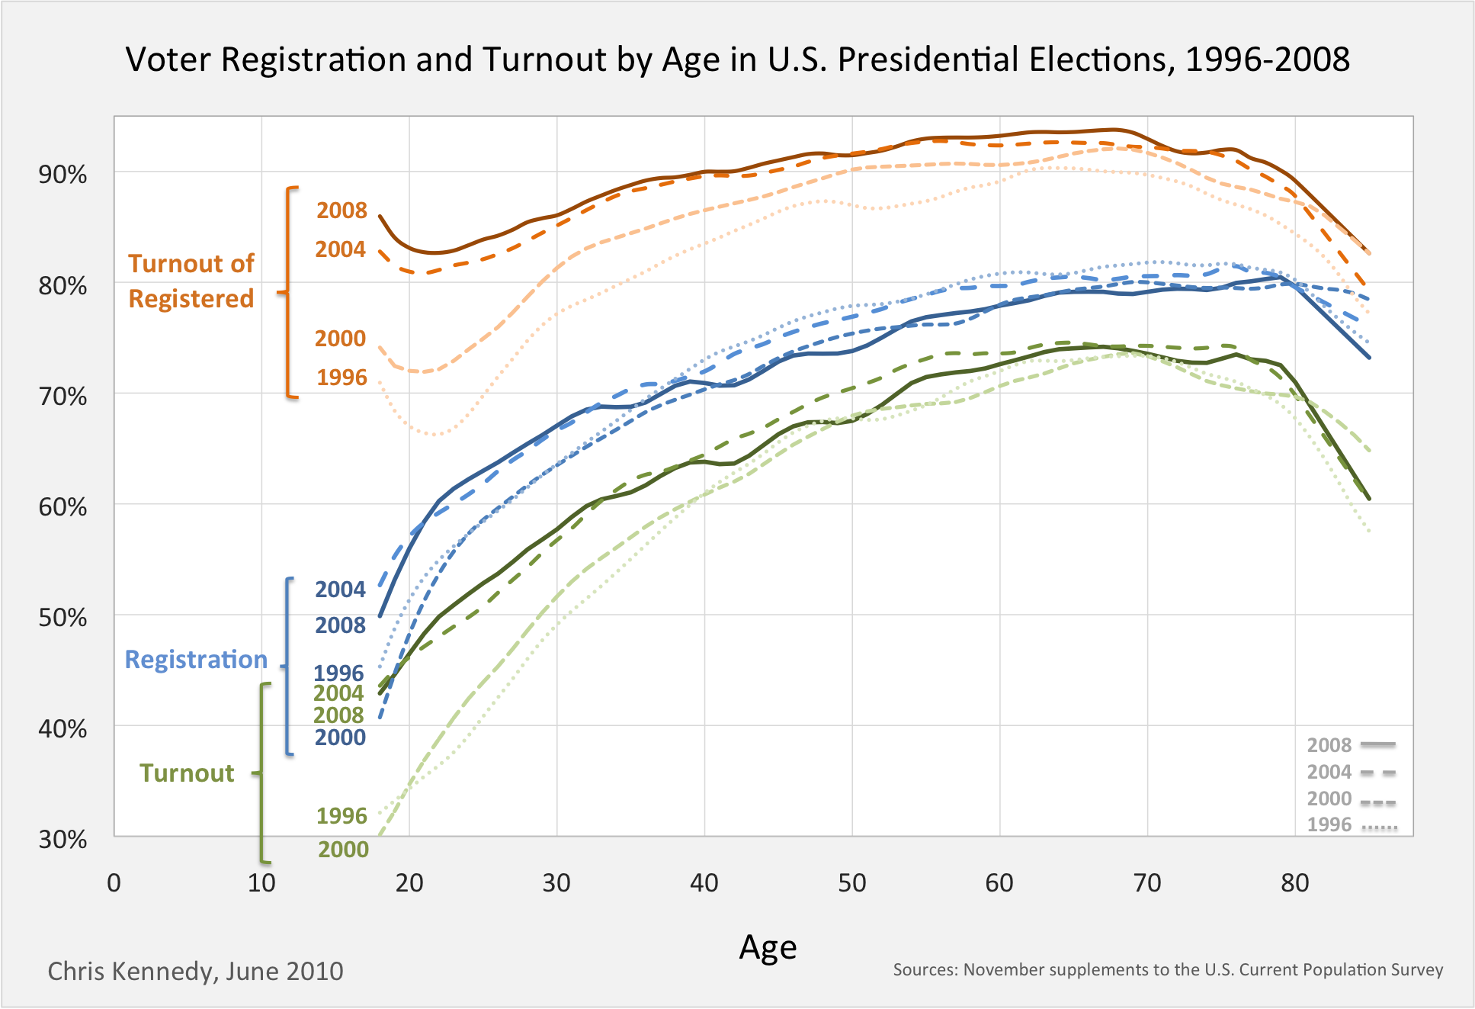
Voter Turnout ⁴
The topic of Pro’s and Cons for the Electoral College system has been going on for over two hundred years. There have been critics and proponents of the system for the entire time and some of the major themes that seem to circle back to the front are often heard.
- Voter turnout may be depressed - Since each State is entitled to the same number of electoral votes regardless of its voter turnout, there is no incentive in the States to encourage voter participation
- The distribution of Electoral votes in the College tends to over-represent people in rural States
- The system fails to accurately reflect the national popular will stems primarily from the winner-take-all mechanism whereby the presidential candidate who wins the most popular votes in the State wins all the Electoral votes of that State⁵

I feel that in our society where every eligible vote should count toward what they are voting on, the need of a system to vote for our voter is outmoded and I feel that I lose my voting power by basically giving it away to someone else to choose for me. Popular and unpopular candidates would have equal footing if each person had the option to choose whom they wanted instead of having to depend on a rigid two party system. As an example you could take an Independent that only had influence in the Western United states, and was extremely effective and popular in states where there is a high population; and that person encouraged higher than average turnout for voting and actually won the Presidency and some states that had low turnout may never even have heard of them. This could not happen in our current system where we are not expressly limited to a two party system, but the hurdles for any candidate to run that was not strictly Democrat or Republican has almost no chance to get their name known in all fifty states and to then be of enough influence for those that are elected to elect to choose them for the position of President, or Vice President.

One vote per eligible voter is definitely the way we should be moving, each state does impose limits and restrictions about how they choose their Electoral College representatives. Committees, groups and individuals devote a great deal of time and effort in the selection processes and procedures; when in actuality we could simplify and streamline the entire process by identifying the people that are eligible to be voted for State by State and at the end of the day let the American with the most votes be our President. By having a method where each voter has one vote it wouldn’t be games, innuendo, manipulation, or corruption that would get someone the big chair; it wouldn’t be feasible for any candidate to speak of coat tails and rewards for the masses that would vote them in. Changing the process may even change the whole aspect of the endless campaign where showing the whole population what can be done, and is done in the position of power would get you known and elected without having to influence those that are already politically inclined and energizing those that are simply of civic mind and demeanor.
Works Cited

- http://www.archives.gov/federal-register/electoral-college/about.html - Internet Reference - NARA
- http://www.archives.gov/federal-register/electoral-college/faq.html#whyelectoralcollege - Internet Reference - NARA
- http://www.archives.gov/federal-register/electoral-college/faq.html#reforms - Internet Reference - NARA
- http://ck37.com/voter-registration-and-turnout-1996-2008 - Internet Reference gathered from 2010 Census data.
- http://uselectionatlas.org/INFORMATION/INFORMATION/electcollege_procon.php - Internet Reference - David Leip 2008

