James Ford
Dina Wecker
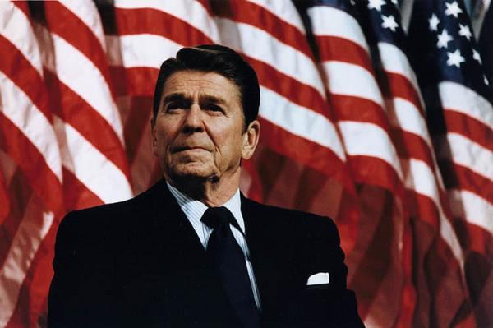
(www.oneangryman.com)
Ronald Reagan’s Legacy Ended by Alzheimer’s Disease
Ronald Reagan accomplished many things as the 40th president of the United States. He helped end the problems with the economy by his methods called Reaganomics. President Reagan ended communism in Russia by making good foreign ties with Mikhail Gorbachev and demanding that he restructure the government of the USSR. (O’Lesseker, par. 44) Gorbachev fell through with the demand due to Reagan increasing defense spending and making the United States the strongest country in the world. (par. 45) One writer even said that he was one of the most significant presidents since Franklin Roosevelt and one of the most loved. (par. 47) He accomplished great things as the President of the United States, but ultimately faced one of his greatest challenges after being the President.
The date was November 5, 1994 and the president had decided to make his challenge known publicly to the American people. The medium he chooses to present his new problem was through a letter, which was written to the American people as a whole. The letter was written in cursive hand writing on paper with the presidential crest on it. The letter used language that showed that the president had accepted what was to come. The challenge that was about to come was Alzheimer’s disease and he knew that no cure was present for the disease. The reason he wanted to go public with the news was to make the American people aware of the disease. The President talked about the cancer he had in the past was made aware to the American people and great things came out of it. (Reagan, par. 2) The President thanked the American people for giving him the greatest honor of being the president and remained optimistic that the United States had a bright future ahead of him. (Reagan, par. 5) The letter was the beginning of a greater challenge facing the President at the end of his life.
Reagan showed signs of having the disease before he officially wrote the letter back in November of 1994. The summer of 1986 was one such time that showed the early signs of Alzheimer’s disease. The main reporter for the White House was Lesley Stahl and she took her family into the oval office to meet the Reagan. Lesley said that when she entered the room the President looked confused as to who she was. (Corn, par. 10) The reporter made a comment to her daughter about the fact that the President worked for her at one time and now she works for the President. (par. 11) The comment brought no emotional response of any kind from the President. (par. 11) She mentioned that her husband was a screenwriter and that sparked the President’s interest. (par. 12) The President was an actor in his early years and he talked about a movie he could star in with her husband. When the family left the President chased after them and told the daughter that he used to work for her mother. (par. 13)
The other incident was seen after his presidency on his 83rd birthday celebration. The celebration was a public event and video recorded by the press. The President was sent up to make a speech and he looked a little bit confused on why he was there. The first minute he didn’t look like the powerful speaker seen during his presidential days. The minute passed and it was like a light switch clicked on and he became his normal self. The secret service member guarding Reagan during the party had to remind him what he was doing there. Reagan had to have his wife tell him what to do in some instances, such as shaking people’s or be prepared to give a speech in front of the people. (“Reagan”) The signs were there early on in his life that Alzheimer’s was progressively taking over.
The primary person to witness the President’s downward spiral from Alzheimer’s disease was his wife, Nancy Reagan. The first lady was interviewed by Mike Wallace when Ronald was in the late stages of Alzheimer’s disease. She recalled their 50th anniversary on March 4, 2002 and was sad about that time. (Kohn, par. 10) She remembered how she wanted to talk to him about their past experiences and the long years of love spent together. (par. 10) Nancy had to stop herself from doing this due to the fact that Ronald would have no recollection of the events that she wanted to talk about. (par. 10) She wasn’t able to celebrate the event with her husband even though he was right by her side the entire day.
The final experience Nancy talks about is the fact that she has made reconciliation with her daughter Patti. (par. 3) The reason she brings this up is the fact that Ronald has no idea they have become great friends now. The President seems confused at the fact that Patti comes over and tries to settle differences that have already been settled. Nancy says that part of him knows they have left behind the past, but the part is hidden behind a cloud of confusion. (par. 4) The settled differences means that Patti helps her mom care for Ronald and the main thing she observed through her father’s battle with Alzheimer’s is the way his eyes have changed over the years. (par. 4) She says at first the eyes have fear of what is to come, but still stand firm. The eyes slowly begin to accept the strangeness of the outside and let the disease take over with the ultimate look of confusion. (par. 4) Family members observed the fact that Ronald Reagan succumbed to the disease that ultimately led to his death.
President Ronald Reagan accomplished many thinks during his two terms as Commander and Chief. He was able to bring down communist Russia and put a definite end to the cold war. He made America the strongest country in the world through increased spending on military defense. He strengthened America’s economy through decreased taxes and increased Federal spending. He showed the great ability to solve major issues facing the American people, but was unable to solve the problem that brought about his demise. Alzheimer’s disease was the ultimate problem that Ronald Reagan could not beat. The disease has no known cure and Reagan was a classic example of how the disease can take down people who have accomplished great things throughout their life. The disease can take a hold of any body and a cure must be found, so no one has to go through what Ronald Reagan went through.
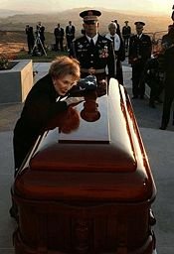

(http://www.news.navy.mil/search/photolist.asp)

Bibliography
- Corn, David. “How Close Did Lesley Stahl Come to Reporting Reagan Had Alzheimer's While in Office? Very Close.” Mother Jones. January 20, 2011. Web. March 11, 2012.
- Kohn, David. “The Reagan's Long Goodbye.” cbsnews.com. June 12, 2009. Web. March 11, 2012.
- O’Lesseker, Karl. “How Great was Ronald Reagan? Our 40th President's Place in History.” The Heritage Foundation. 2012. Web. March 11, 2012.
- Reagan, Ronald. Letter. November 5, 1994. Print March 11, 2012.
- Reagan. Narr. David Ogden Stiers. PBS. Natl. Television aired 1998. Web. March 11, 2012.

